

**INSTITUTE OF AERONAUTICAL ENGINEERING**

**(**Autonomous**)**

**Dundigal, Hyderabad - 500 043**

**Title Of The Project**

**“MANUFACTURING OF READY-MIX CONCRETE BY USING NEW**

**TECHIQUES AT ICON READY CONCRETE, MEDCHAL RD, HYDERABAD”**

**Submitted By**

GANDU PRAKASH

Roll No.21955a0105

Department: Civil Engineering

Under the Guidance of

B.Bhavani

Assistant Professor



**INSTITUTE OF AERONAUTICAL ENGINEERING**

**(**Autonomous**)**

**Dundigal, Hyderabad - 500 043**

**MENTOR DETAILS**

# 1. Student Details

|  |  |
| --- | --- |
| Name of the Student | GANDU PRAKASH |
| Roll Number | 21955A0105 |
| Department | Civil Engineering |
| Year / Semester | II Year, IV semester |
| Mobile Number | 8555082859 |
| Email ID | 21955a0105@iare.ac.in |

# 2.Mentor Details

|  |  |
| --- | --- |
| Name of the Mentor | B Bhavani |
| Organization | Institute of Aeronautical Engineering |
| Designation | Assistant Professor |
| Email ID | bbhavani@iare.ac.in |
| Mobile Number | 7674024526 |

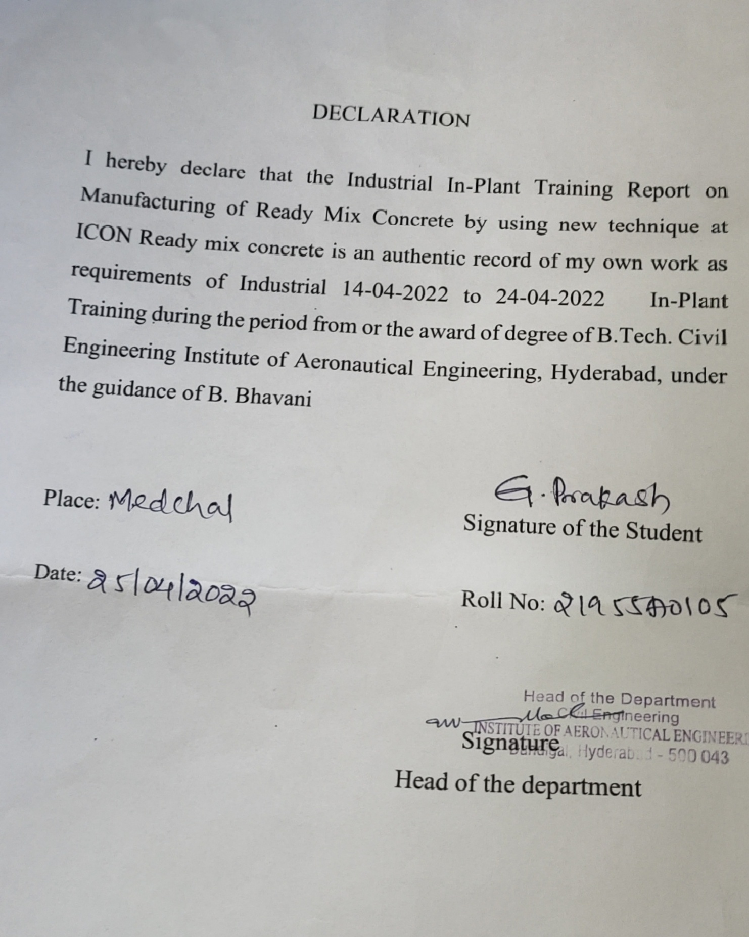

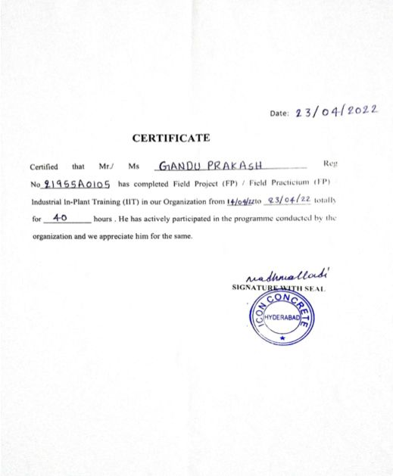

**TABLE OF CONTENTS**

|  |  |  |
| --- | --- | --- |
| **S.NO** | **CONTENTS** | **PAGE NO** |
| **1.** | Title of the project | 1 |
| **2.** | Student & Mentor Details | 2 |
| **3.** | Declaration Form | 3 |
| **4.** | Certificate | 4 |
| **5.** | Table of Contents | 5 |
| **6.** | Title, Purpose, Objectives & Description | 6-7 |
| **7.** | Introduction | 7 |
| **8.** | Materials | 7-9 |
| **9.** | Procedure | 10-13 |
| **10** | Conclusion | 14 |

**Title of the field project**

**“MANUFACTURING OF READY MIX CONCRETE & QUALITY CONTROL AT ICON RMC”**

# Purpose

* They are used to provide ready mix concrete utilizing a continuous batching process or metered concrete system.
* The volumetric mobile mixer is a truck that holds sand, rock, cement, water, fiber, and some add mixtures and color depending on how the batch plant is outfitted.
* The most important function performed by this plant is that it coats the aggregates with cement.
* Some aggregates need consistent mixing with cement, and water in those case additives may be added.

# Objectives

* The main objective is to manufacture high-quality fresh concrete, proper mixing of materials is critical.
* The surface of all aggregate particles is coated with cement paste during the mixing phase.
* For the desired workability and performance of concrete in both the fresh and hardened states.
* To avoid segregation and bleeding.

# Description

We went to “ICON RMC PLANT”, Medchal Rd which is near Gandimaisamma, Hyderabad. This RMC plant consists of silos and bins for the storage of cement and aggregates respectively, weigh batchers for proportioning different ingredients of concrete, high efficiency mixer for thorough mixing of ingredients, and a computerized system controlling the entire production process

**1. INTRODUCTION:**

Ready Mix Concrete is a ready-to-use material which is a mixture of **Cement, Sand, Aggregate and Water**. RMC is a type of Concrete which is mixed in a batching plant according to the specification of the customer and delivered to the site by the use of transit mixer as it is away from the construction site.

**2. MATERIALS USED IN RMC:**

1. Cement
2. Fine aggregate
3. Coarse aggregate
4. Admixtures

**2.1 CEMENT:**

Cement, in general, adhesive substances of all kinds, but, in a narrower sense, the binding materials used in building and civil engineering construction.

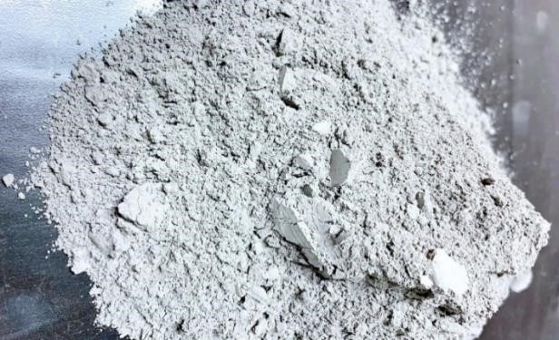

## Fig 1: Cement

**2.2 FINE AGGREGATES:**

Fine aggregates are essentially any natural sand particles won from the land through the mining process. Fine aggregates consist of natural sand or any crushed stone particles that are ¼” or smaller. This product is often referred to as 1/4'” minus as it refers to the size, or grading, of this particular aggregate.

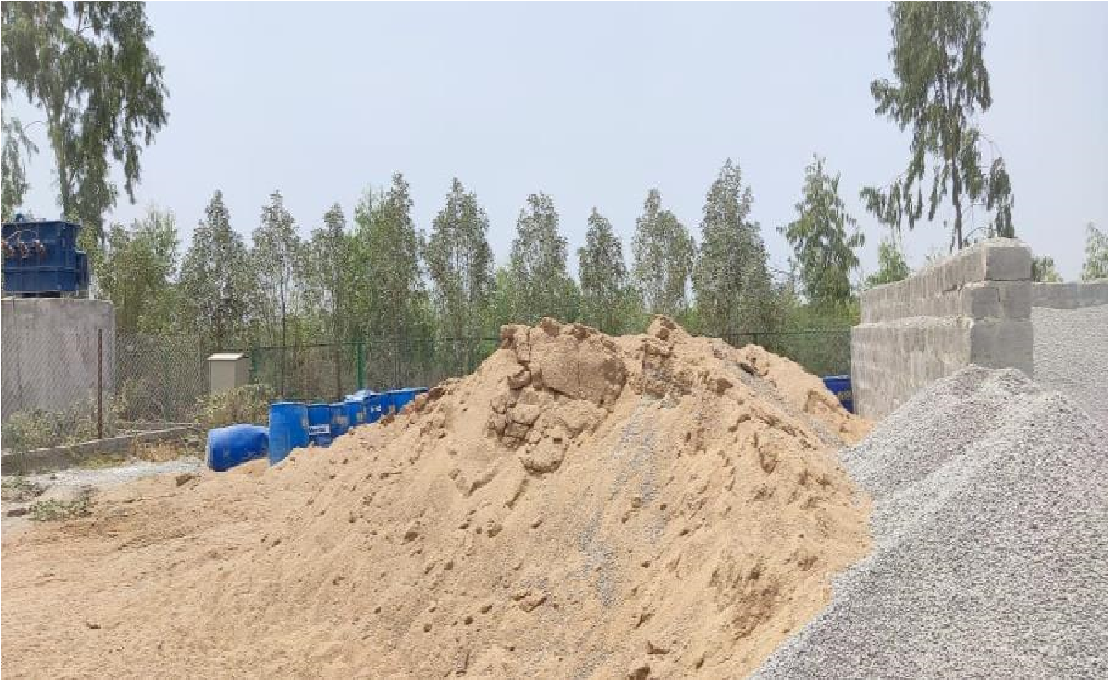

**Fig 2: Fine Aggregate**

**2.3 COARSE AGGREGATE:**

Coarse aggregates are any particles greater than 0.19 inch, but generally range between 3/8 and 1.5 inches in diameter. Gravels constitute the majority of coarse aggregate used in concrete with crushed stone making up most of the remainder.

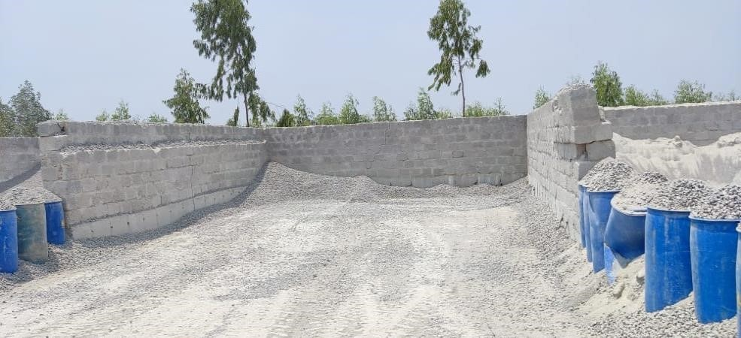

## Fig 3: Coarse Aggregate

**2.4 ADMIXTURE:**

An admixture is defined as “a material other than water, aggregates, cementitious materials, and fiber reinforcement, used as an ingredient of a cementitious mixture to modify its freshly mixed, setting, or hardened properties and that is added to the batch before or during its mixing”.

**3. MANUFACTURING OF RMC:**

## 

## Fig 4: Aggregate Batching Plant

**3.1 BATCHING:**

Batching of Concrete stands for the method of estimating and mixing the required concrete ingredients with both weight or volume according to the mix design and transplanting them into the mix to create a consistent quality of concrete. Batching of Concrete is usually done with volume.

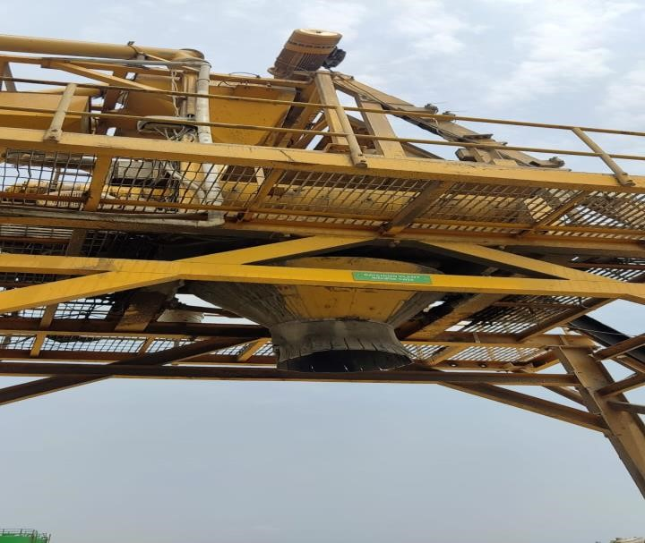

## Fig 5: Batching plant

**3.2 MIXING**:

There are two types of ready-mix plants:

* A central mixing plant uses a stationary mixer to mix the concrete. The concrete is then transferred into the transportation vehicle.

* A truck mixing plant places all unmixed dry materials into a truck mixer. Water is added and mixing is then done in the truck.

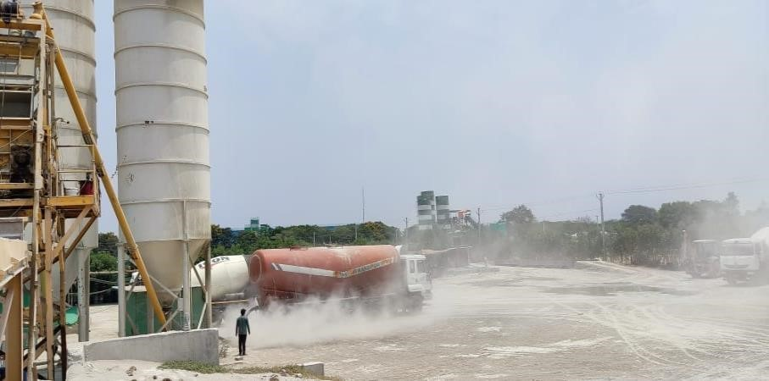

## Fig 6: RMC Over view

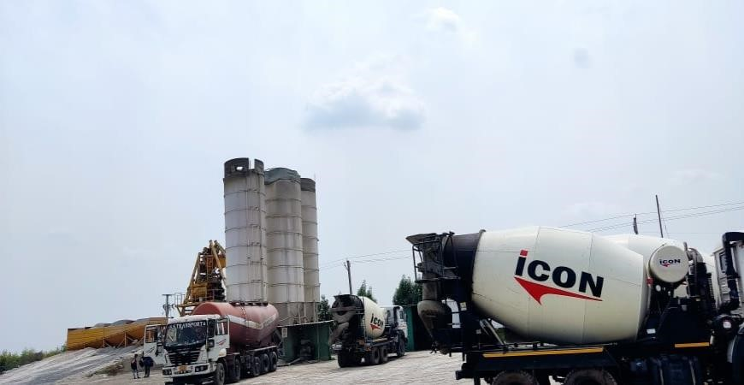

**Fig 6: RMC Plant**

## 4. TESTS ON FINE AGGREGATES

1. Sieve Analysis
2. Specific Gravity
3. Bulk Density (Loose / Rodded)
4. Silt Test by Volume / Weight
5. Water Absorption
6. Sulphite / Chloride / Alkali Reactivity
7. Organic Impurities

## 5. TEST ON COARSE AGGREGATES

1. Sieve Analysis
2. Specific Gravity
3. Aggregate Impact Value
4. Bulk Density (Loose / Rodded)
5. Water Absorption

6. Flakiness Index

1. Elongation Index

## 6. TEST ON WATER

1. pH Value
2. Chloride
3. Sulphite
4. Nitrite

